CLIPPING MASK TUTORIAL

A CLIPPING MASK is an object whose shape masks other artwork, so you only see the shapes inside the clipped area.
- CLIPPING SET: The clipping mask and the objects that are masked.
- Clipping Masks are a great way to keep shapes cropped while also being able to edit the shapes

HOW TO MAKE A CLIPPING MASK (a short demo)
- Using the SHAPE TOOL, create multiple shapes: rectangle (M) or ellipse (L)
  - Shapes can overlap one another
- Using the shape tool again, we are going to make the mask: make one large shape that is ON TOP of the other shapes
  - Select all shapes> OBJECT> CLIPPING MASK> MASK (⌘7)
    - You will notice that everything OUTSIDE of the top shape will disappear, that means you are doing it right!!

FAQ’s
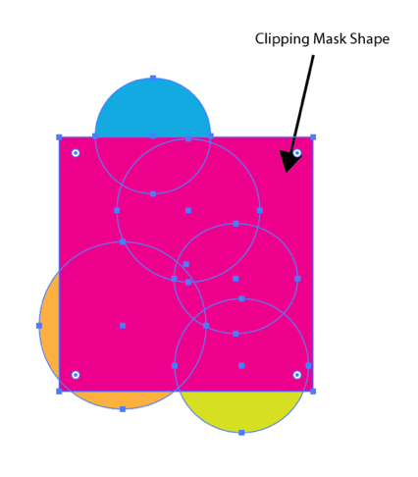
Q: My clipping set is not the shape I wanted.
A: Make sure the shape you are clipping with is the TOP shape, and that all shapes you want to clip are selected
To bring the shape to the front: Object> Arrange> Bring to front (⌘⇧])

Q: I cant select the shapes in my clipping set.
A: When you make a clipping mask all the objects are grouped into the clipping set. Double click the clipping set to access the items in the clipping mask.
Q: I want to take away the clipping mask
A: No problem!!! Select the CLIPPING SET and go: OBJECT> CLIPPING MASK> RELEASE (⌥⌘7) and all the shapes within the clipping set will be released from the clipping mask.

